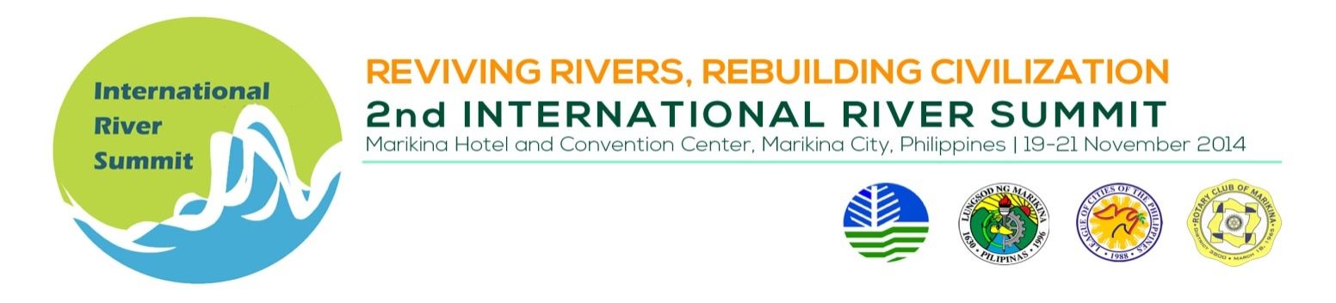
CLOSING CEREMONIES

Venue : Convention Center Plenary Hall

Date/Time : November 21, 2014, 1:30 – 3:00 PM

TIME | TOPIC
 | Highlights of the 2nd Int’l River Summit | Dir. Lourdes Wagan  Regional Director, National Capital Region - Department of Environment and Natural Resources
 | Presentation of the Marikina Declaration | Mayor Del R. De Guzman  Marikina City Mayor
 | Solidarity Messages | Hon. Secretary Ramon JP. Paje, Department of Environment and Natural Resources (DENR)
 | Solidarity Message  and Turnover of IRS Banner to the Next Host | League of Cities of the Philippines/  Mayor, host city
 | Awarding of Plaques of Recognition for  Hon. Franklin S. Drilon, Philippine Senate President  Hon. Jed Patrick M. Mabilog, Mayor, Iloilo City (host city, 1st IRS) | Hon. Secretary Ramon JP. Paje, Department of Environment and Natural Resources  Del R. De Guzman, Secretary-General, League of Cities of the Philippines / Marikina City Mayor  Hon. Oscar S. Moreno, National Chairman, League of Cities of the Philippines
 | Introduction of Senate President Franklin Drilon | Rep. Miro Quimbo  2nd District, Marikina City
 | Solidarity Message | Hon. Franklin S. Drilon  Senate President
 | Message of the Guest of Honor | His Excellency BENIGNO S. AQUINO III  President, Republic of the Philippines
 | PHOTO SESSION
 | END OF 2ND INTERNATIONAL RIVER SUMMIT
4:00 PM | CITY TOUR (OPTIONAL) | c/o Marikina City Tourism, Culture and the Arts Office

